Accessibility
Disabled and wheelchair-bound patients.
Access is through the main door.
There are two parking bays designated for disabled patients in the staff car park to the front of the surgery.
- Please display your blue badge.
- Access to the surgery is:
  - via the gentle slope in front of the main doors, at the side of the disabled parking bays
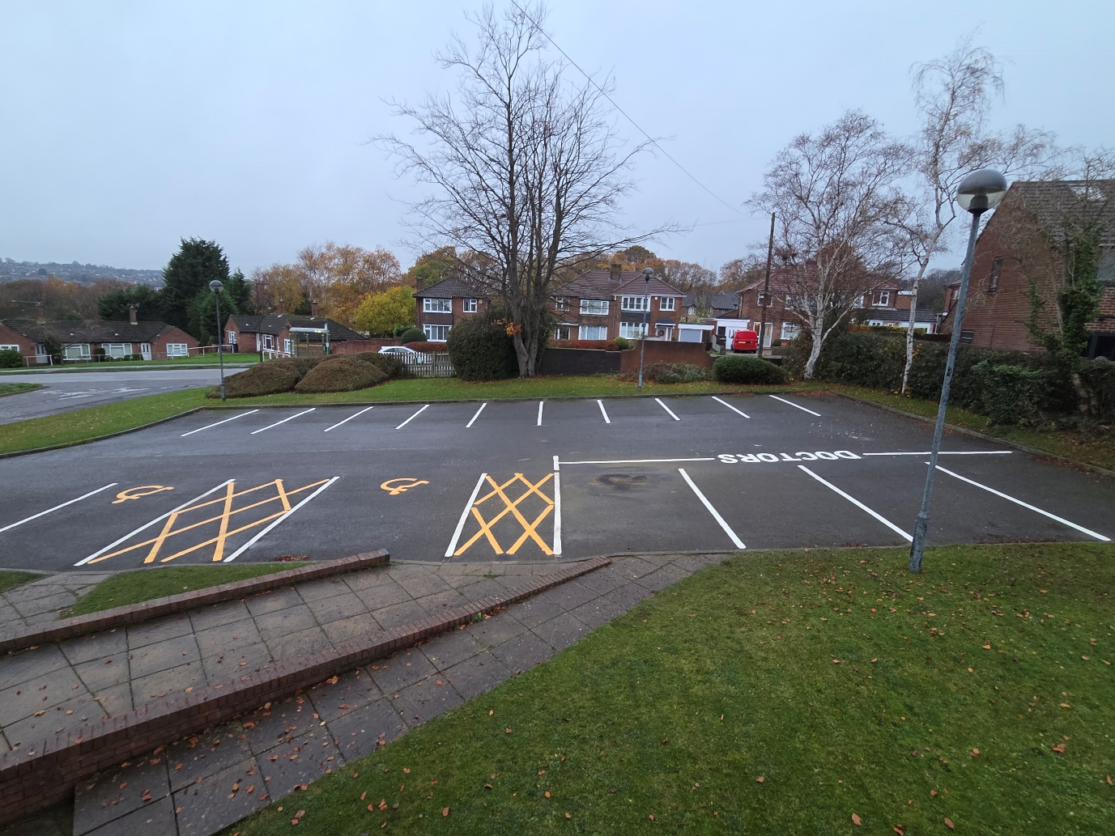
Wheelchair access

We have a wheelchair available for use when attending the surgery.
- Please ask at reception.
There is an accessible toilet available near the reception desk in the corridor.

Hearing difficulties
If you are experiencing hearing difficulties when being called in to see the doctor or nurse, please let us know. An alert will be set up on your medical records and you will be collected from the waiting room.
We do have the facility of a portable induction loop. If you would like to use this, please ask at reception.

Sight difficulties
If you are experiencing difficulties seeing the screen calling you in to see the doctor or nurse, please let us know. An alert will be set up on your medical records and you will be collected from the waiting room.
If you have any special communication needs (e.g. large print, easy read documents etc.) please inform the reception staff and we will note these on your medical records. You are able to request information in different formats.
- For further information visit www.easyhealth.org.uk. The Department of Health also have resources we can order on your behalf.

Web site
Our web site has accessibility options.
- Select the person on the right-hand side of the screen. 

Neurodiversity
The waiting room is quieter at the end of the day.
- Please ask when booking an appointment.

Language
Translation services can be available, we do have to book these in advance, and are not always available the same day, therefore your appointment may have to be booked a few days in advance.

